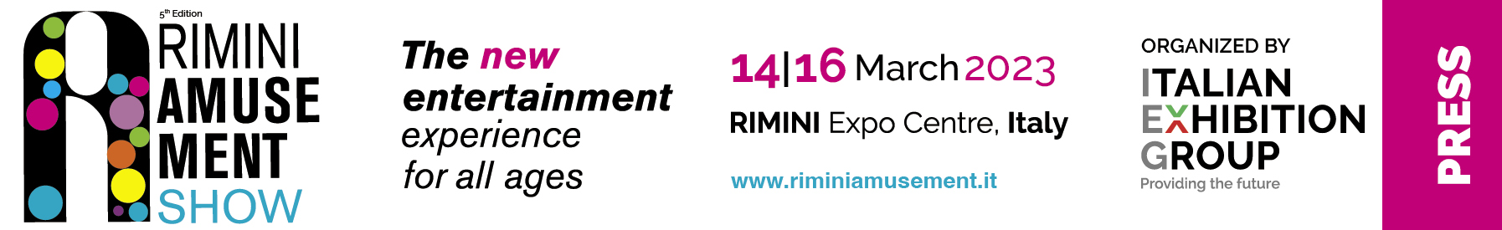

press release
(English translation)

FROM PINBALL TO THE METAVERSE,
EVENTS AT THE RIMINI AMUSEMENT SHOW

For the first time in Italy, an Esports and gaming event has landed on the Metaverse
thanks to the collaboration between EspoGame and The Nemesis.
And with the Luxury Games tournament, sports pinball could not go amiss.
The appointment, in conjunction with Enada, is from March 14th to 16th
at Rimini Expo Centre

Rimini, 1st February 2023 – Rimini Amusement Show has landed on the Metaverse with a first time in Italy event dedicated to Esports and gaming with no cash winnings. The occasion will be marked by EspoGame, the new section, organised by Italian Exhibition Group in collaboration with the Italian Esports Observatory and Sport Digital House, scheduled to take place on Wednesday 15th and Thursday 16th March.
Thanks to the partnership between EspoGame and The Nemesis, (a preview of what can be seen during the show can be found on: https://thenemesis.io/@zebulive using Chrome), users will have the chance to enjoy an immersive experience and benefit from further content from the speakers and companies in attendance at the show. This content will also be available for viewing five days prior to the start of the event and fifteen days after its closure. Prestigious brands have confirmed their attendance and will be telling their case histories. These include Barilla, Red Bull, Dolce & Gabbana, LG, RAI, Acer and Xiaomi, to mention but a few. Moreover, thanks to the “business match making” model, new companies and start-ups at the show will be able to present their projects and attract potential investors. EspoGame is also one of the gaming and web3 world’s most important moments of the year to reflect and be inspired by some of the sector’s leading experts: from Fabio Viola (one of the top names in gamification) to Fortuna Imperatore (one of the most innovative profiles in game design), and Micaela Romanini (founder of Women in Games Italy). More names will be revealed in the coming weeks, with 40 speakers, 4 special guests and a total of 600 minutes of talks, panels and speeches.

The JJP Pinball Fest by Luxury Games is back
Sports pinball could not go amiss among the events at the show with the Luxury Games tournament (Hall C3, stand 88-89), valid for the WPRR (World Pinball Player Rankings) global classifications and organised in collaboration with Ifpa Italia, the amateur sports association. The competition will take place over the three days of the show from Tuesday 14th to Thursday 16th March and will be disputed exclusively on Jersey Jack Pinball machines in their most coveted versions: from Toy Story: collector to Wizard of Oz: yellow limited, from Pirates of the Caribbean: collector to Guns'n Roses: collector and Willy Wonka: limited. Besides the ranking points, also at stake are a vintage cabinet 3300 games for the winner, a 32” television for second place and a smartphone for the person who comes in third. For further information: www.ifpaitalia.it

PRESS CONTACT media@iegexpo.it
head of corporate communication & media relation: Elisabetta Vitali; press office manager: Marco Forcellini; international press office coordinator: Silvia Giorgi

FOCUS ON ITALIAN EXHIBITION GROUP
Italian Exhibition Group S.p.A., a joint stock company listed on Euronext Milan, a regulated market organised and managed by Borsa Italiana S.p.A., has, with its facilities in Rimini and Vicenza, achieved national leadership over the years in the organisation of trade shows and conferences. The development of activities abroad - also through joint-ventures with global or local organisers, in the United States, United Arab Emirates, China, Mexico, Germany, Singapore, Brazil, for example – now sees the company positioned among the top European operators in the sector.

This press release contains forecast elements and estimates that reflect the management’s current opinions (“forward-looking statements”), particularly regarding future management performance, realization of investments, cash flow trends and the evolution of the financial structure. For their very nature, forward-looking statements have a component of risk and uncertainty, as they depend on the occurrence of future events. The effective results may differ (even significantly) from those announced, due to numerous factors, including, only by way of example: food service market and tourist flow trends in Italy, gold and jewellery market trends, green economy market trends; the evolution of raw material prices; general macroeconomic conditions; geopolitical factors and evolutions in the legislative framework. Moreover, the information contained in this release, does not claim to be complete, and has not been verified by independent third parties. Forecasts, estimates and objectives contained herein are based on the information available to the Company as at the date of this release.

